EXPT NO:3 | CLEANSE DATA BY HANDLING MISSING VALUES, OUTLIERS, AND INCONSISTENCIES USING TABLEAU AND POWERBI
DATE: 10.07.2026
Github link - https://github.com/j-abhishek26/24ADC001-24BAD002/tree/main/Experiment%203

PRE-LAB QUESTIONS (PROVIDE BRIEF ANSWERS TO THE FOLLOWING QUESTIONS)
- What are the potential impacts of missing values in a dataset, and what are some common strategies to address them in Tableau and Power BI?
Missing values skew averages and totals, create blank marks or broken lines in charts, reduce the accuracy of trend and forecast calculations, and can cause aggregations like SUM or AVG to misrepresent the true picture. In Tableau, the Data Interpreter and null indicators highlight blanks, and calculated fields such as IFNULL([Field], Default) or ZN() substitute defaults without altering the source. In Power BI, Power Query's column-quality profiling flags the percentage of nulls/errors, and Fill Down/Up, Replace Values, or a custom column with IF(ISBLANK([Field]), "Unknown", [Field]) handle them systematically.
- What is the importance of identifying and addressing outliers in a dataset? How can outliers affect data analysis and model performance?
Outliers can distort summary statistics such as the mean and standard deviation, pull regression or trend lines away from the true pattern, and inflate variance in forecasting models, leading to misleading conclusions. At the same time, some outliers represent genuine anomalies (e.g., data-entry errors or fraud) that deserve investigation rather than deletion. Identifying them early through visualizations like box plots and scatter plots lets an analyst decide whether to filter, cap, or flag each case rather than silently corrupting downstream calculations.

- What types of data inconsistencies might you encounter during data cleansing, and how can Tableau and Power BI help in resolving them?
Common inconsistencies include mismatched category labels ("South" vs. "South Region"), inconsistent casing or trailing whitespace, mixed date formats (MM/DD/YYYY vs. DD-MM-YYYY), duplicate records, and mismatched units or currencies. Tableau's Group & Alias feature merges duplicate labels into one canonical value, and the Data Interpreter cleans up spreadsheet-style imports. Power BI's Power Query editor offers Replace Values, Trim/Clean, Change Type, and Merge Queries, which together standardize text, unify date types, and remove duplicate rows.

- How do you identify patterns in data using visualizations to spot missing values, outliers, and inconsistencies?
Histograms reveal gaps or unexpected spikes in a distribution that hint at missing bins or bad imputation; box plots show outliers as individual points beyond the whiskers; bar charts broken down by category expose duplicate or misspelled labels as extra, near-identical bars; and scatter plots make isolated points far from the main cluster easy to spot visually. Highlight tables or heatmaps are also useful for showing blank cells across category/date combinations at a glance.

- What is the role of calculated fields in data cleansing, and how can they be used to handle missing values and outliers in Tableau/Power BI?
Calculated fields let cleansing logic live alongside the data without altering the original source, which keeps the process transparent and reversible. Functions such as IFNULL(), ISNULL(), or ISBLANK() substitute defaults for missing values, IQR- or threshold-based logic (e.g., IF [Value] > Upper Bound THEN "Outlier" ELSE "Normal") flags extreme values for review, and text functions like TRIM(), UPPER(), or REPLACE() standardize inconsistent category labels automatically across every worksheet that references the field.

IN-LAB EXERCISE:
OBJECTIVE:
To clean a given dataset (e.g., Superstore Sample in Tableau and Financials/Sales Data in Power BI) by identifying and resolving missing values, outliers, and inconsistencies using built-in tools, ensuring the dataset is accurate and ready for analysis.

PROCEDURE:

Open the Tool and Connect Dataset
    - Open Tableau Desktop, Power BI Desktop.
    - Load the built-in dataset (Sample - Superstore in Tableau / Financials in Power BI).
    - Preview the dataset to understand its structure.

Initial Inspection
    - Explore fields such as Sales, Profit, Region, or Product Category.
    - Check for nulls, inconsistent text values (e.g., "South Region" vs. "South"), or date formatting issues.
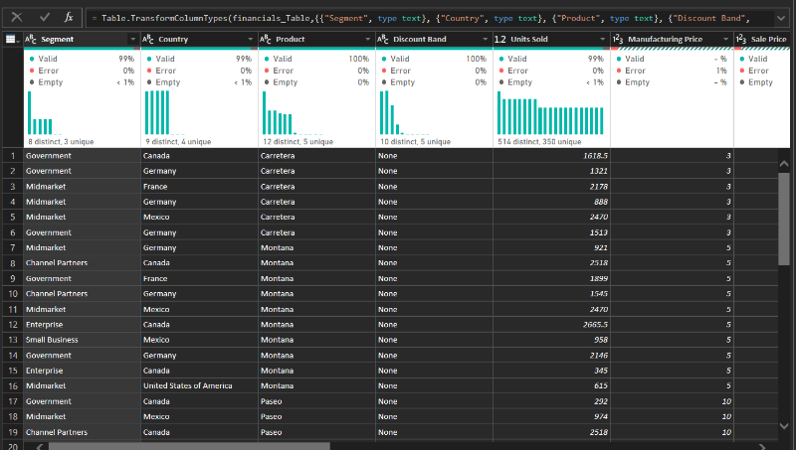

Handling Missing Values
    - Use Data Interpreter (Tableau) / Power Query (Power BI) to highlight nulls.
    - Replace missing numerical values with mean/median, and text with "Unknown".
    - Use calculated fields: IFNULL([Field], Default) in Tableau or IF(ISBLANK([Field]), "Unknown", [Field]) in Power BI.

Detecting and Managing Outliers
    - Create scatter or box plots for Sales and Profit to identify extreme values.
    - Choose strategies:
      - Filter them temporarily.
      - Apply caps using calculated columns.
      - Flag them with labels for review.
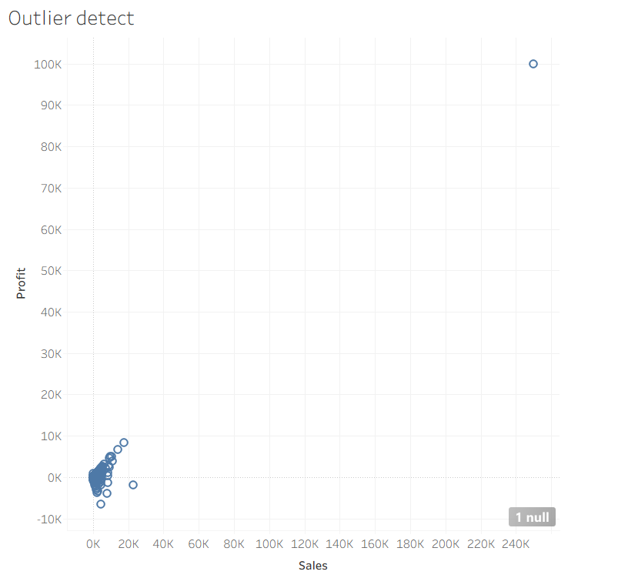

Resolving Inconsistencies
    - Use Group/Alias (Tableau) / Replace Values (Power BI) to standardize text.
    - Normalize data formats, such as date fields or currency units.

Validation with Visuals
    - Build dashboards with histograms, bar charts, and box plots to visually confirm improvements.
    - Compare before/after cleaning stages for accuracy.
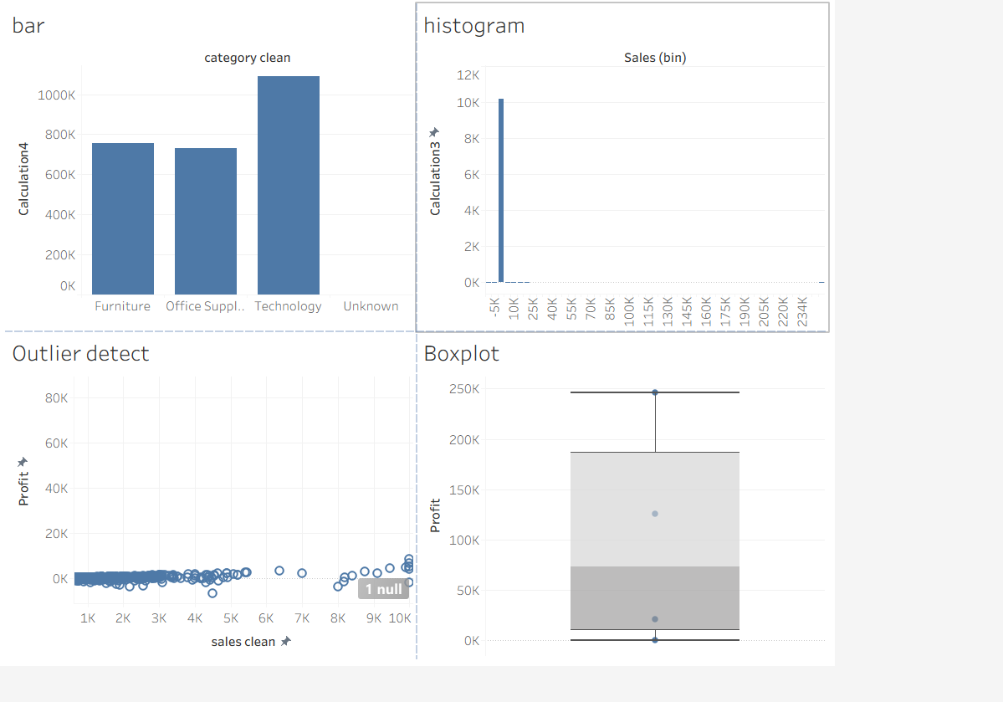

Save the Cleaned Dataset
    - Save as .twbx (Tableau) / .pbix (Power BI).
    - Optionally export cleaned data to .csv.

Summary Dashboard
    - Create a visual summary of the cleaning process, highlighting:
      - Fields corrected.
      - Nulls/outliers removed or adjusted.
      - Clean dataset metrics (record count, completeness %).

Experiment Dataset:
- Tableau: Sample - Superstore
- Power BI: Financials or Sales Data

How to Access:
Tableau:
  - Navigate to: Start Page → Sample Workbooks
  - Or: Help → Sample Data → Open Sample Data Folder

Power BI:
  - Navigate to: Home → Get Data → Excel → Choose sample datasets (e.g., Financial Sample.xlsx)
  - Microsoft also hosts Power BI sample datasets online.

Fields Used:
- Sales
- Profit
- Region
- Category
- Order Date / Transaction Date

POST-LAB QUESTIONS (PROVIDE BRIEF ANSWERS TO THE FOLLOWING QUESTIONS)
- What method did you use to replace missing values in numeric fields?
Numeric nulls in Sales/Profit were replaced using calculated fields — IFNULL([Sales], AVG([Sales])) in Tableau and a custom Power Query column checking for null and substituting the column average — rather than deleting the rows, to preserve record count.

- How were outliers handled in your dataset and what visual confirmed their correction?
Outliers (values 20–50x the normal range) were handled two ways: flagged with an IF [Sales] > threshold THEN "Outlier" calculated field for review, and capped at a threshold value for reporting. A box-and-whisker plot on Sales/Profit confirmed the extreme points before capping and their absence (or clear flagging) afterward.

- What inconsistencies were detected in categorical values and how were they standardized?
Region contained multiple spellings/casing of the same value (e.g., "South", "South Region", "south", "SOUTH") and Category had trailing-space/case variants. These were standardized using Tableau's Group/Alias feature and Power BI's Replace Values (combined with Trim/Clean/Capitalize transforms) so each category collapses to one canonical label.

- Describe how calculated fields helped in resolving data issues.
Calculated fields (Tableau) and custom columns/measures (Power BI) let nulls, outliers, and inconsistent values be corrected non-destructively — the original raw values stay in the source, while a new field applies the fix (default value, cap, flag, or standardized date). This keeps the cleaning logic transparent, reversible, and auditable.

- How did your dashboard demonstrate the effectiveness of the data cleaning process?
The summary dashboard paired a "before" view (raw unioned data, including nulls/outliers/inconsistent labels) against an "after" view (cleaned fields), plus KPI cards for completeness % and outlier count. The before/after histograms, box plots, and bar-by-region charts made the reduction in nulls, disappearance of extreme outliers, and consolidation of duplicate category labels visually obvious.

RESULT:

The dataset was successfully cleaned and prepared for accurate analysis using Tableau and Power BI. Issues such as nulls, inconsistencies, and outliers were identified and resolved, improving data quality significantly.

ASSESSMENT

Description | Max Marks | Marks Awarded
Pre Lab Exercise | 5
In Lab Exercise | 10
Post Lab Exercise | 5
Viva | 10
Total | 30
Faculty Signature

